Topics covered

We can add data items in the initialize page of an object .Eg number datatypes of global timeout – small/medium/large and unhide it so that it can be used in other pages

Use collection data item with column name as Path to add it to the collection

Try without giving any column name

Application Modeller for Web

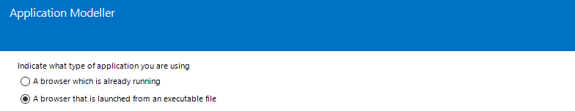

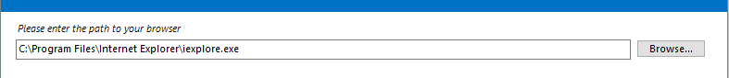









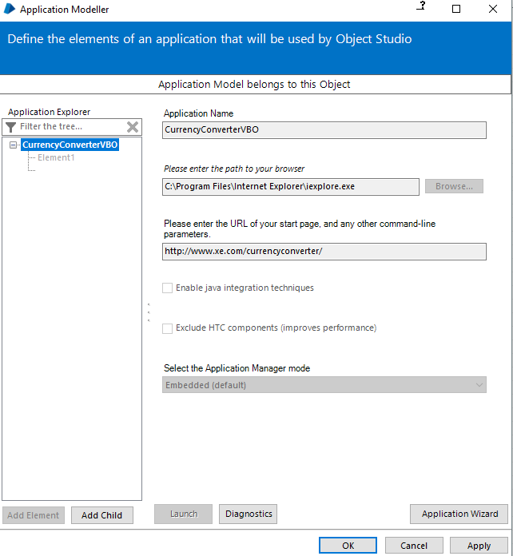

To change Application Modeller settings, click on the Application Wizard button.

Pending: chrome doesn’t work, identify what can be done as an alternative

On identifying an element with ctrl+ left click

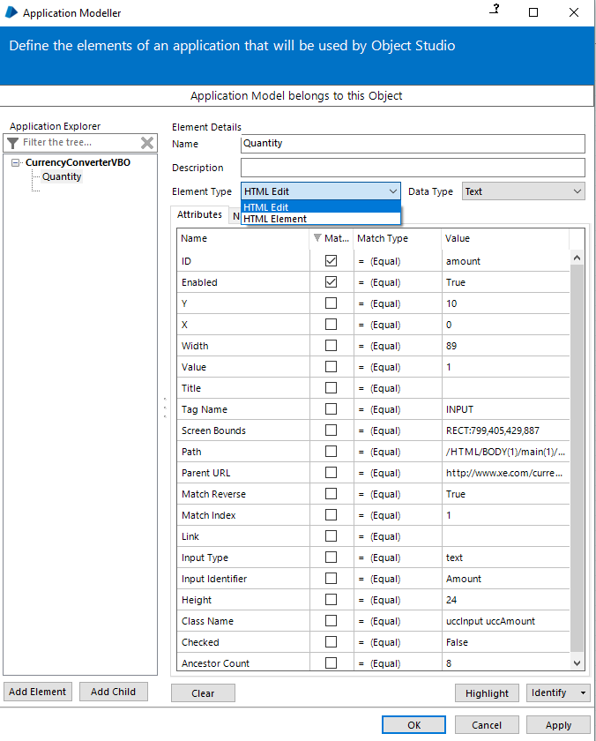

Pending : Difference between HTML Edit and HTML Element

Relative xpaths do not work in the path column. Also even if one property mismatches, identification will fail

Fastest identification is via path, rest takes times

When an element with tag button is identified, element type option change

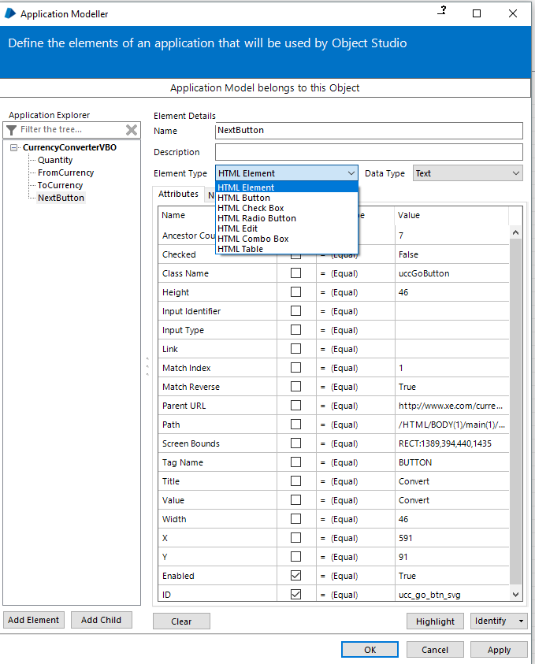

Pending: change these values and see how they affect action stage (navigate/read) options

Issue that was found is – it also identifies elements in next page even if they are not there if we have navigated once atleast. For eg in currency converter app, if we navigate to result page and go back to main page and highlight from field, it will show multiple highlighted and hence fails when running. Use matching index in such cases

Navigating/Clicking button options

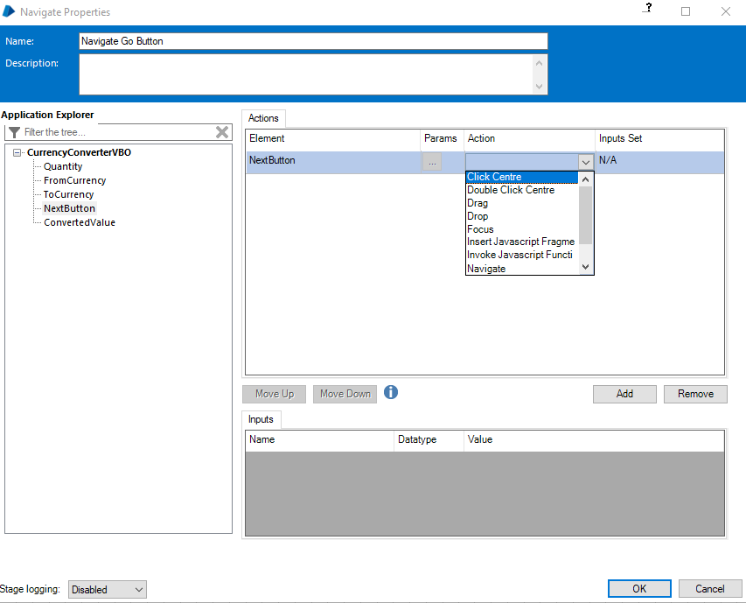

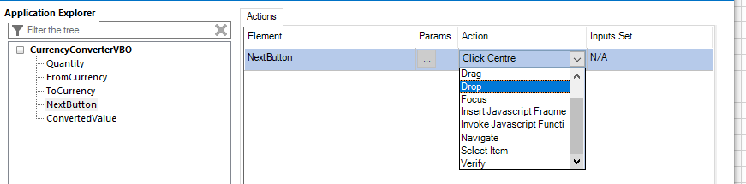

Pending: Try all these options

Reader properties

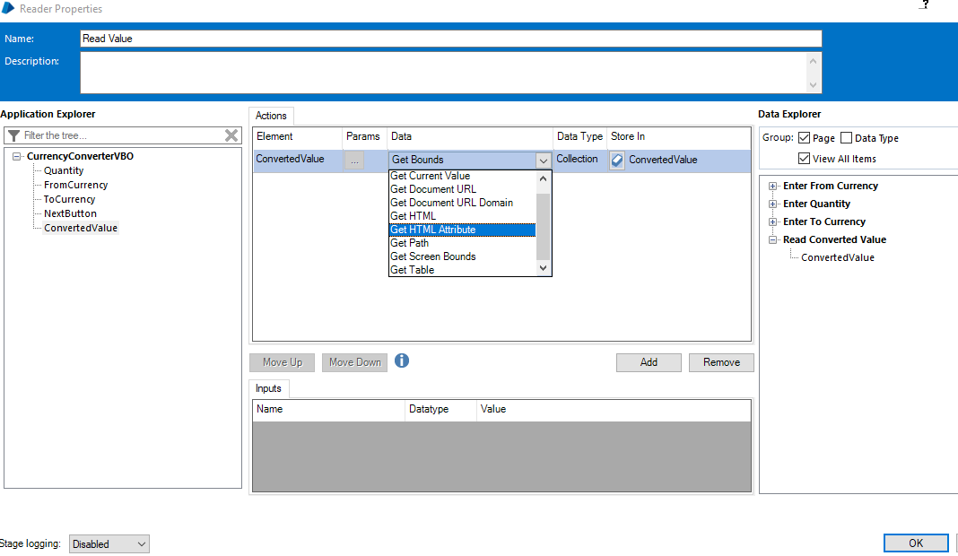

Pending : Add Wait Stage

We can add properties in initialize page for global wait time of different sizes and unhide them from all pages

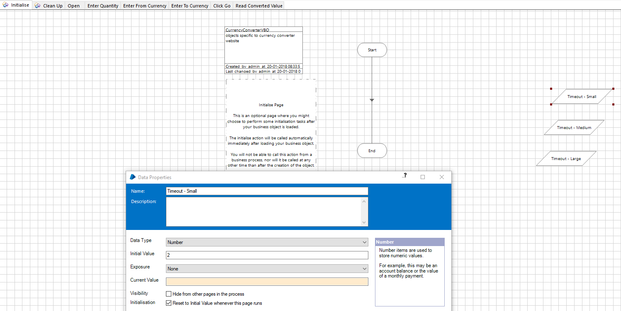

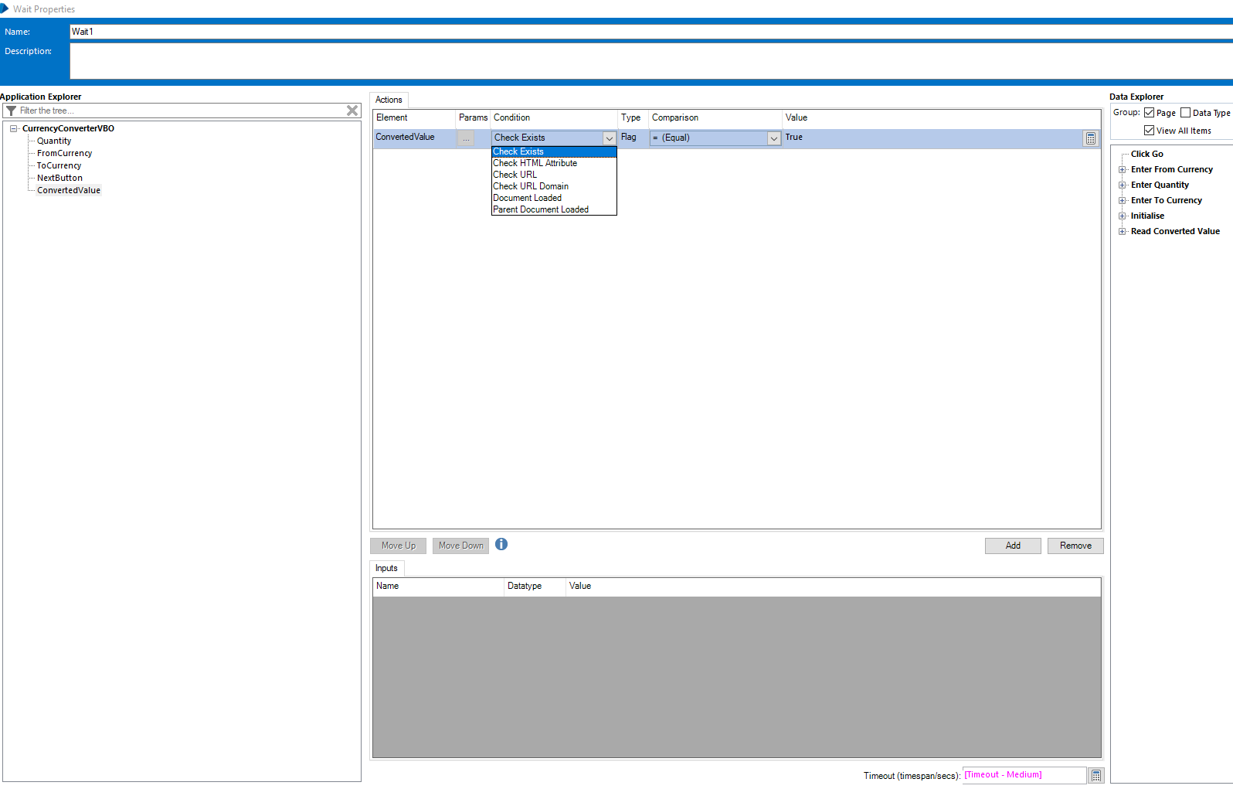

Timeout in second is parameterized from initialise page

Convert text value to number and then perform rounding operations (calc/multicalc stage)

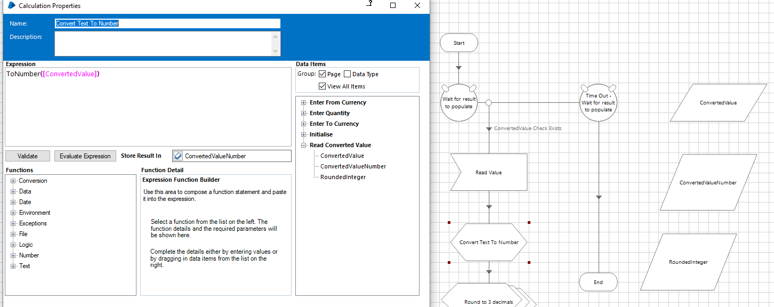

Use the tool to “paste” value into the expression box

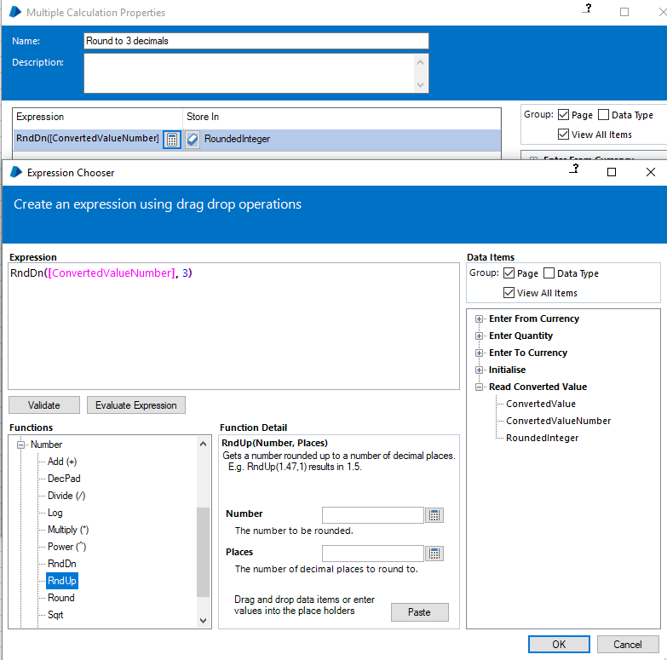

**Gmail configurations**

For Gmail

MyAccounts >Sign in and security >Allow less secure apps >ON

In blueprism, import “BPA Object - Email - POP3_SMTP.xml”

Get configurations from gmail site

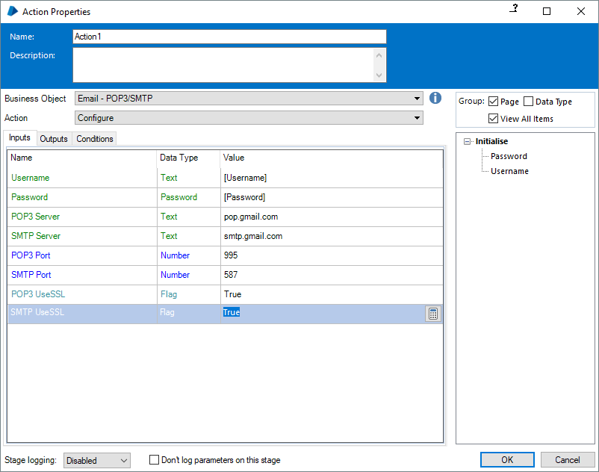

Field Name should be path only

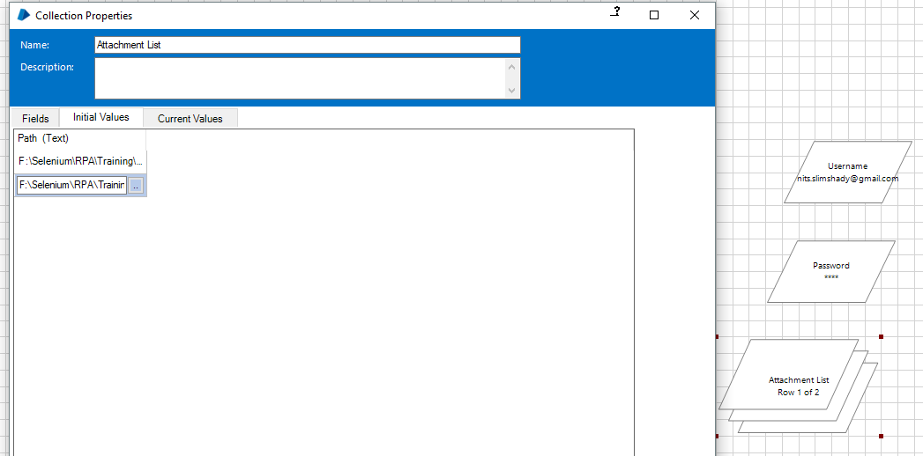

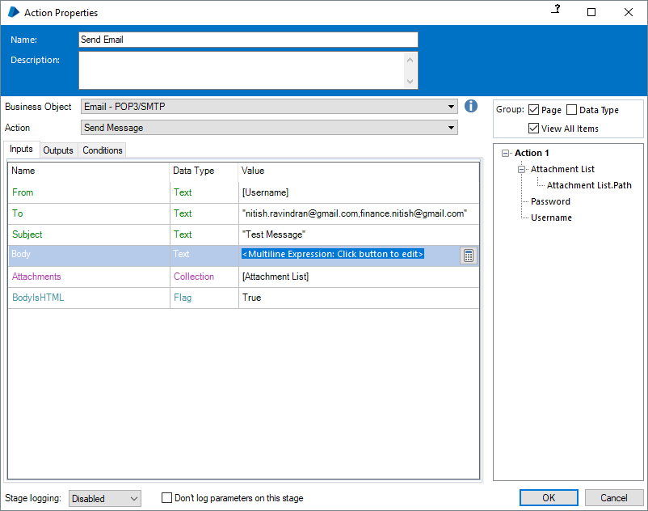

The configure gmail action stage can also be put in initialize page of the object, it will always be called immediately on loading business object (verified)

Once an object is published, it cannot be deleted. Must be moved to retired list

From Settings>Object>Management

Active🡪Retired can only be done with admin access(TL /Manager)

